Detecting Subtle Sequence Singals：A Gibbs Sampling Strategy for Multiple Alignment
C. E. Lawrence, S. F. Altschul, M. S. Boguski and S. Karlin
Science, 262:208-214, 8 October 1993
Abstract
Introduction：
- Global multiple alignment
- Local multiple alignment
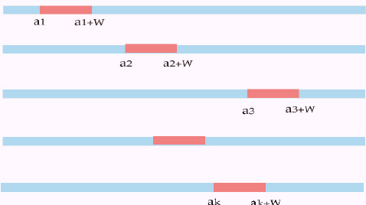
Problem and methods：
We assume that we are given a set of N sequences S₁,…,S_{N} and that we seek within each sequence mutually similar segments of specified width w.
The model we use has three fundamental characteristics. First, we seek a relatively small number of sequence elements or patterns, each consisting of one ungapped segment from each of the input sequences. Second, a single pattern is described by a probabilistic model of residue frequencies at each position. Third, the location of the pattern within the sequences is described by a set of probabilistically inferred position variables.
The basic algorithm：
  - Predictive update step.
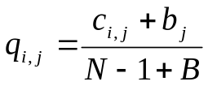
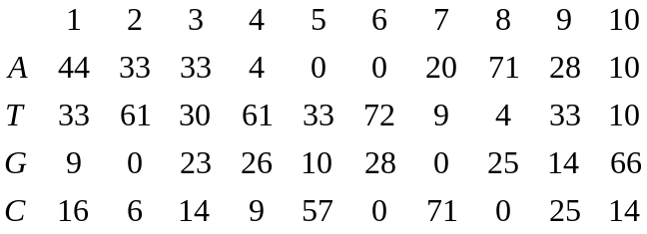
“pseudocounts”: If the estimated number of motifs was 20 and the default pseudocount weight of 0.1 was used, there would be (42/100) * 0.1 * 20 = 0.84 pseudocounts added to the count for an A in position 1.
  - Sampling step.
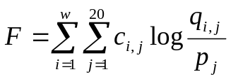
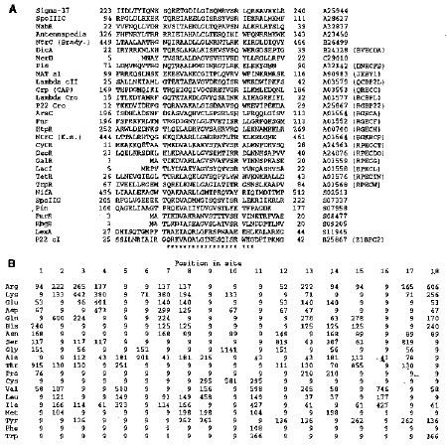
Created by: Ying-Jer Liao
Date: August 15, 2002

